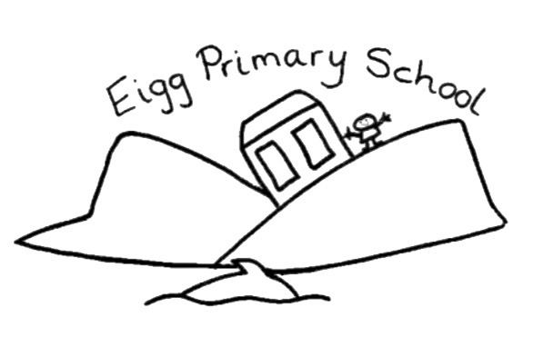

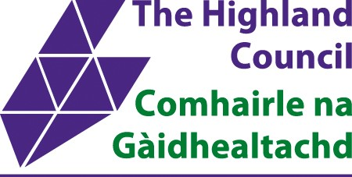
Eigg Primary School
And
Nursery
Handbook
2026/2027

Contents Page

Head Teacher’s Welcome……………………………………………………page 3
School Information………………………………………………………………page 4
Ethos of the School………………………………………………………………page 5,6
Curriculum Rationale and Design………………………………………..page 5,6
Curriculum for Excellence……………………………………………………page 7
Learning, Teaching and Assessment………………………………… page 9, 10, 11, 12
What the Curriculum Looks Like………………………………………. page 13,14
Named Person…………………………………………………………………………page 16
Protection of Children………………………………………………………… page 16
Supporting Positive Behaviour and Anti-bullying…………….page 17
Equality, Diversity and Inclusion…………………………………………page 17,18
School Inspection……………………………………………………………………page 18
Transition……………………………………………………………………………….. page 19
Health and Safety………………………………………………………………….page 20, 21
Attendance/Absence…………………………………………………………….page 21 & 22
School Uniform and Lunches……………………………………………… page 22
School Lunches……………………………………………………………………….page 22
School Transport……………………………………………………………………page 23, 23
Enrolment…………………………………………………………………………………page 23
Placing Requests – Parental Choice……………………………………..page 23 and 24
Complaints and Requests for Service…………………………………page 24
Data Protection……………………………………………………………………….page 25, 26
Employment of Children…………………………………………………………page 27
Education Maintenance Allowance……………………………………….page 27
Adverse Weather……………………………………………………………………page 27
Policies……………………………………………………………………………………… page 27
Military Families………………………………………………………………………page 27
Head Teacher’s Welcome
Dear Families, A Chàirdean Chòire
We are very proud of our primary school and nursery on the Isle of Eigg, a small Hebridean Island off the West Coast of Scotland, and I am delighted as the Head of Eigg Primary and Nursery to welcome you to our school handbook.
The whole school community is committed to building positive relationships and creating a warm, caring atmosphere where children are encouraged to develop a growth mind-set and take ownership of their learning journey. The present role for the primary school is 9 children, and they are taught in one multi-composite class. This means that there are lots of opportunities for the older children to develop their skills through teaching the younger members of the class, as well as carefully planned learning experiences that allow individuals to progress and be the best they can. The our nursery, children are provided with rich play-based learning opportunities and spends much of their time learning with their primary school friends and younger island children, who visit frequently.
Our school building consists of one primary classroom, a nursery and an office and one auxiliary space. Works have been approved to convert our auxiliary space into a modern nursery and we look forward to sharing progress with you. Children undertake PE in the island’s community hall – around two miles from the school. The school grounds have plenty of room for the children to use their imaginations whilst playing. There is a mud kitchen and a large grass area and a school garden with a poly tunnel where the children grow fruits and vegetables. Having the opportunity to learn outdoors is very important at Eigg Primary and Nursery.
Every member of staff works hard to make our school an exciting place to learn by providing rich, relevant and enjoyable learning experiences that challenge and motivate all learners. I hope that this handbook will help give you a taste of what it is like to be part of Eigg Primary School and Nursery, but if you would like any more information or would like to visit the school please get in touch.
Kind Regards,
Kieran MacInnes
Head Teacher, Eigg Primary School and Nursery.
Kieran.MacInnes@highland.gov.uk
01687 482 424

School Information

Contact Details
Eigg Primary School
Isle of Eigg
Inverness-shire
PH42 4RL

Phone Number: 01687 482424
Email: eigg.primary1@highland.gov.uk
Website: eiggprimary.com

School Staff:
Head Teacher: Kieran MacInnes
Class Teachers: Martin Merrick and Jenna MacDonald
PE Teacher: Eilidh MacGilp
Early Years Practitioner: Jenna MacDonald
General Auxiliary: Babette Apma
Clerical Assistant: Katrin Bach
Cleaner: Richard Moult
Janitor: Katrin Bach

Parent Council:
Chair – Rolling Chair - Contact Details - EiggPrimary@highlandpc.co.uk
Primary School
Present Roll: 9
School Hours:
9am – 3pm

Nursery
Present Roll: 1
Nursery Hours: 9am – 3.00pm

Denominational Status: Non-denominational

Our primary language of instruction is English. Gaelic and French are also taught and celebrated.
Cluster: Eigg Primary School and Nursery shares a head teacher with Muck Primary School and Nursery, Isle of Muck.

Ethos of the School
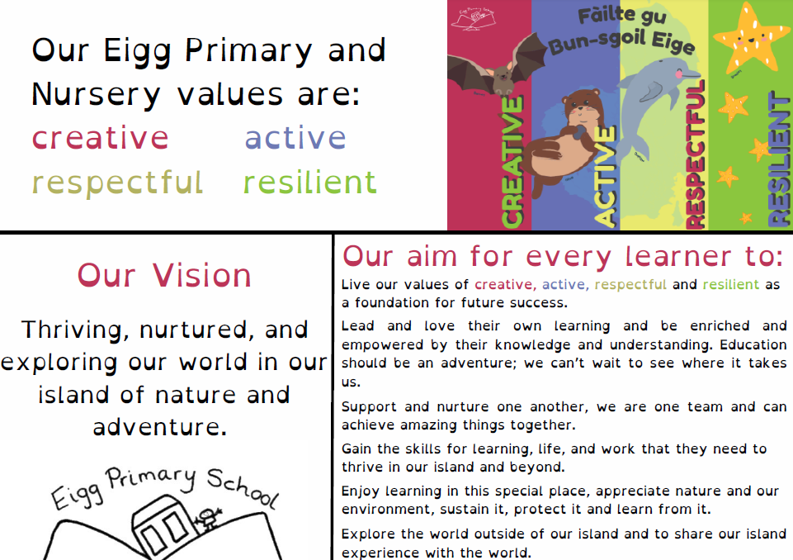
Curriculum Rationale and Design
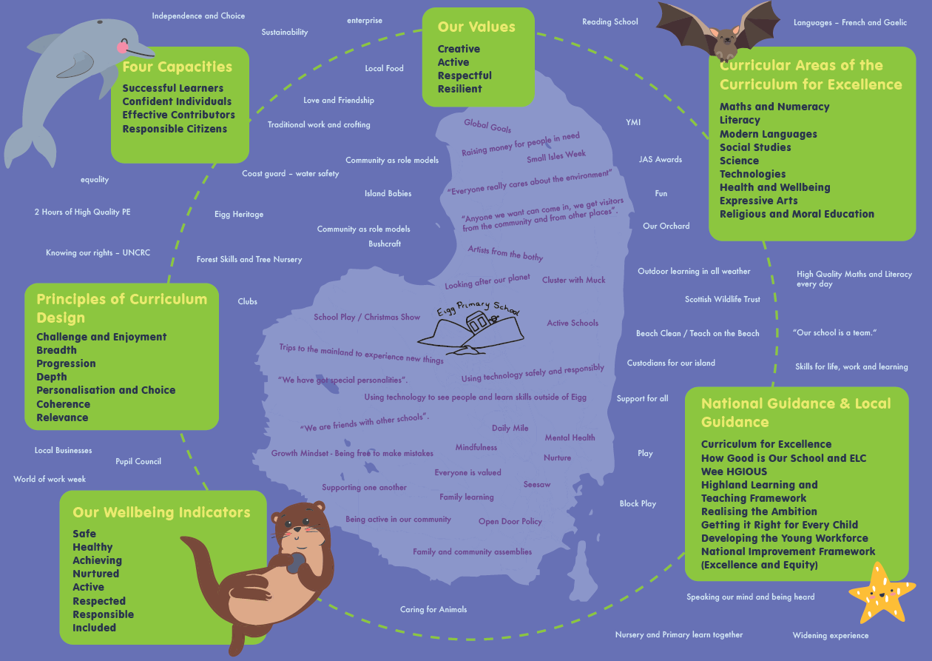
Our whole school – pupils, staff, parents and partners – came together to renew, refresh and relaunch our school vision, values and aims. Our values underpin everything that we do at Eigg Primary and Nursery.
To make our shared aims and vision a reality, we all came together to create a new curriculum rationale for our school, that reflects our unique community, location and our unique personalities. The children’s ideas from their floor book were integral to this.
We are continually striving to make our school the best it can possibly be. You can find a link to our school improvement plans here: A link to this session’s Quality Improvement Report and School Improvement Plan can be found our school website A hard copy can be obtained by contacting the school.
Curriculum for Excellence
In Scotland we use the Curriculum for Excellence (CfE) to help us deliver a well-balanced, coherent and challenging curriculum that will help our learners from 3 to 18, gain the knowledge, skills and attributes they need to succeed in learning, life and work. The term curriculum is understood to mean everything that is planned for children and young people throughout their education, not just what happens in the classroom.
The Curriculum for Excellence includes four contexts for learning:

- Curriculum areas and subjects
- Interdisciplinary learning
- Ethos and life of the school
- Opportunities for personal achievement

The Four Capacities  These are the skills and attributes that we are helping our learners to develop.  - Successful Learners  - Responsible Citizens  - Effective Contributors  - Confident Individuals  The Seven Principles  These are taken into consideration at every stage of the learning journey:  - Challenge and enjoyment  - Breadth  - Progression  - Depth  - Personalisation and choice  - Coherence  - Relevance. | The Eight Curriculum Areas:  Expressive Arts – Art, Drama, Music and Dance  Health and Wellbeing (HWB) – personal, social and mental health. P.E is included in this curriculum area.  Languages - listening and talking, reading, writing and modern languages.  Numeracy and Mathematics – Number,  Shape, Information Handling and Problem Solving.  Religious and Moral Education – Religions, Values and Beliefs  Sciences – Understanding the living, material and physical world.  Social Studies – Understanding our Past. Understanding our Environment. Understanding Society, Economy and Business  Technologies – Food, Design and the Digital World

Learning, Teaching and Assessment
We have created a handy guide to share what learning and teaching looks like at Eigg Primary School. You can find out lots more about our approaches to learning, teaching and assessment via our Learning, Teaching and Assessment policy here.
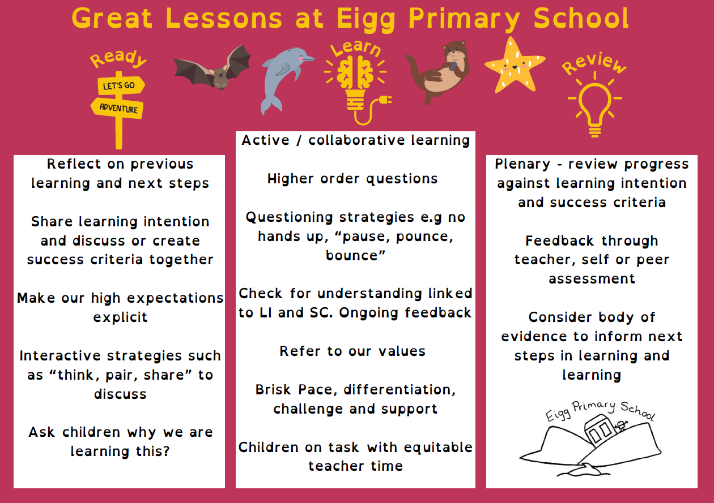
Curriculum for Excellence
At Eigg Primary and Nursery, we think carefully about how we organise and plan for deep, sustained learning which meet the needs of all our learners. Sometimes curriculum areas will be taught discreetly, with the expectation that the learners will be given the opportunity to transfer any skills or knowledge that they have developed or gained to another situation at a later date.
Revisiting a concept or skill from different perspectives deepens understanding and can make the curriculum more coherent and meaningful for learners. At other times learning may span a number of curriculum areas at once. This is called interdisciplinary learning or IDL. It is a method of planning and teaching that can lead to a better, more rounded understanding of important ideas and to an increased competence in using knowledge and skills in transferable ways.

Curriculum Levels
There are three levels within the primary school. They are Early, First and Second. There is no fixed age or stage for completing the levels but they are roughly Early Nursery-P1, First P2-P4 and Second P5-P7. Our learners progress through these levels at their own pace and we aim to meet the learning needs of all children.

Developing Skills for Learning, Life and Work
Developing skills for learning, work and life plays an integral part of curriculum design at Eigg Primary and Nursery. Every member of staff works to provide a wide range of meaningful and relevant learning contexts where learners can develop new skills or strengthen existing ones.

Community Links
The school is an integral part of life in Eigg, making a positive social and environmental contribution to island life. The pupils organise and participate in community events, including social evenings and beach clean-ups. We enjoy welcoming visitors into our school and hearing about their skills and jobs.

Pupil Voice
All our children have the opportunity to lead learning and improvement in our school. Pupils’ interests and learning styles help direct the way in which the curriculum is designed and accessed.

Outdoor Learning
We are very lucky to work, learn and live on a beautiful island and believe in making the most of the natural environment. Our learners already have many learning opportunities outside and we look forward to strengthening this together. We hold an outdoor learning afternoon every Friday – where primary and nursery learners explore the wonder of the outdoors and learn in rich outdoor contexts.

Trip and Visitors
Visitors to the school and trips, both on and off Eigg, help to create a rich, broad and relevant curriculum for our learners. We make use of digital technologies to enrich the learning experience for our children and allowing them to interact with other learners and skilled individuals from outside of Eigg. We visit our cluster school in Muck regularly, which supports our learning and teaching. For example, this allows us to play team games in a larger group. We also maintain close links with schools on the mainland and with our friends in Rum and Canna.

Assessment
Assessment is a way of supporting learning. It helps teachers, learners, parents and others to understand the depth and breadth of learning undertaken so that progress and next steps can be discussed and planned.

Children’s progress is not only based on 'tests' but on the learning that takes place within the classroom and in different settings outwith the classroom.

Evidence of children and young people's progress and achievements will come from day-to-day learning and through the things they may write, say, make or do. For example, evidence may emerge as a result of children and young people taking part in a presentation, discussion, performance or practical investigation. Evidence could also be a drawing, report, or piece of art work that they have produced. Evidence may be captured as a photograph, video or audio clip as part of a particular learning experience. Children also undertake more formal “summative” assessments at various times during the year, including the Highland Numeracy Diagnostic, Scottish National Standardised Assessments and Progress in Reading and Progress in Understanding Maths Assessment.

At Eigg Primary school we follow an assessment calendar which is updated regularly – this ensures consistency and quality of learning.

Supporting Pupils
We work hard to ensure that all learners can access the curriculum. Sometimes learners will need additional support to ensure that they are making the best progress they can. The needs of these learners are generally catered for within the normal curriculum but with specialist advice and support as required. If necessary, a child’s plan may be put in place to help plan, organise, monitor and regularly review a child’s progress. Parents/Carers and learners will always be involved in discussions about any proposed additional support.
More information can be found about the Highland Council model for support and child’s plans at:
http://www.highland.gov.uk/downloads/file/230/highland_practice_model_-_delivering_additional_support_for_learners
http://www.highland.gov.uk/download/downloads/id/11/co-ordinated_support_plan

Support for Learners Website

Additional support can be found at:

- Enquire – the Scottish advice and information service for additional support for learning
- My Rights, My Say – an advocacy and advice service for young people over 12 with additional support needs
- Scottish Independent Advocacy Alliance, an advocacy service to support parents and children
- Scottish Child Law Centre, an organisation providing free legal advice to young people

Reporting
Children and young people need high-quality feedback about their progress and a clear understanding of the support that is in place to help them succeed. Parents and families must have access to information that allows them to form a clear understanding of how their child is progressing, and the information they need to help them play a key role in their child’s education.

All children own and maintain a dedicated profile using the platform Seesaw.

We continuously report to parents about the progress of their child throughout the year in various ways, including –
- Continuous sharing of learning and profiles on Seesaw and with Google Sites
- Sharing of Learning and showcasing events
- Parents’ Evenings (twice a year)
- End of year Report
- Regular informal communication through strong working relationships
- School Blog posts – created by our learners
- Termly Community Newsletters

We pride ourselves on being a welcoming supportive school. We have an ‘open door’ policy and will always endeavour to respond to an queries or requests within 24 hours or sooner.

Parental Involvement

Parents and guardians are valued partners of Eigg Primary School. Parents can support our school by joining our active parent council, which meets termly, attending family learning events, engaging with the children’s online profiles and supporting learning at home.

Parent / guardian views are a key part of our school improvement process, and school improvement plans are shared and discussed with all parents and generated using the views of families.
We are always keen to hear from parents and guardians who wish to support the work of the school by coming in to volunteer to share their skills and experiences. The children particularly love when parents and others from the community come in to read to them. We would love to hear from anyone who would like to come in.

After-school Clubs

We recognise the important role that our school has in our island setting. We provide termly after school clubs where all island children are welcome. This has included a running club, sewing club, film club, art club and family Gaelic classes. Children’s interests and ideas are the basis for our clubs.

Home Learning

Children take home a reading book each night and are encouraged to read with their families and share their thoughts in their reading diary. Class teachers may issue additional homework at certain points, and this will be communicated to parents / guardians. You can see our Homework Policy here, as agreed with pupils and parents.

Informing Parents About Sensitive Aspects of Learning
At Eigg Primary School, we understand the importance of keeping parents informed about sensitive aspects of learning. Topics such as relationships, sexual health, parenthood, and drugs awareness are introduced as part of the Curriculum for
Excellence in an age-appropriate and sensitive manner. Parents will be informed in advance when these subjects are scheduled, including details of the content and delivery. We value parental input and will provide opportunities to discuss any concerns or questions during scheduled meetings or via direct communication with the class teacher. Parents wishing to view the materials used can request access through the school office.

Religious Instruction and Observance
Eigg Primary School is committed to fostering an inclusive environment that respects the diverse beliefs and values of our community. Religious instruction and observance are provided in line with the Highland Council’s guidance, promoting understanding and respect for various faiths and worldviews. Parents who wish to exercise their right to withdraw their child from religious instruction or observance should contact the Head Teacher. Alternative arrangements will be made to ensure that pupils continue to receive meaningful and inclusive learning experiences during these times.

What the Curriculum Looks Like at Eigg Primary and Nursery

Curriculum Area | Possible Learning Experiences
Expressive Arts  - Participation in performances and presentations  - Art and Design  - Dance  - Drama  - Music | - Christmas play  - Gaelic song / Participation in the Mòd  - Visiting theatre groups  - Fèisean nan Gàidheal – music tuition and cèilidh dancing  - Youth Music Initiative and Kodaly  - Discrete art projects and those linked to other areas of the curriculum  - Art club  - Visiting artists from the Bothy Project
Health and Wellbeing  - Mental, emotional, social and physical wellbeing  - Planning for choices and change  - Physical education, Physical Activity and Sport  - Food and Health  - Substance Misuse  - Relationships, Sexual Health and Parenthood | - Learning about the “Zones of Regulation”  - SHANARRI activities  - Developing a growth mind-set  - Using the Community Hall for P.E  - After school opportunities  - Cooking and baking using produce from the school garden/community orchard  - Values focused assemblies  - Outdoor learning whenever possible

Languages  Literacy and English  - Listening and Talking  - Reading  - Writing | - Emerging Literacy  - Daily Active Writing  - ‘Talk for Writing’  - Research and note taking skills  - Opportunities to present a topic of interest to an audience  - Reading for enjoyment  - Reading challenges  - Non-fiction and fiction writing  - Literacy opportunities across the curriculum
Modern Languages  - Listening and Talking  - Reading  - Writing | - A languages strategy called ‘1+2 Languages’ is in place across Scotland. At Eigg Primary we are learning Gaelic (L2) and French (L3). We attempt to recreate an immersive environment whenever possible and are fortunate to have Gaelic speaking staff members and fluent speakers of French in the community who support us.
Mathematics  - Number, Money and Measure  - Shape , Position and Movement  - Information Handling | - Problem solving and real-life challenges e.g.  - Fundraising for the school  - Fundraising for local and global causes  - Baking in the nursery and classroom  - Mapping the local environment  - Sharing out snack  - Island Data handling excercises  - Using the water trays to experiment with volume  - Creating shapes with the loose parts equipment  - Designing necklaces using patterns
Religious and Moral Education  - Christianity  - World religions  - Development of Beliefs and Values | - learning about the world religions with large followings  - developing an awareness and respect for the beliefs and values of others  - developing their own beliefs and values  Religious Observance  - Eigg Primary is a non-denominational school.  - The school chaplain (Church of Scotland) visits when on the island.  - Parents can request the withdrawal of their child from religious observance
Sciences  - Planet Earth  - Forces, Electricity and Waves  - Biological Systems  - Materials  - Topical Science | - Newton Room Workshops  - Scottish Wildlife Trust  - Bird Week Scotland  - Seasonal Outdoor Learning  - Caring for the local and global environment  - Developing the skills of observation, investigation, exploring and recording  - Opportunities to their knowledge and experiences of the world around them
Social Studies  - People, Past Events and Societies  - People, Place and Environment  - People in Society, Economy and Business | - Developing the skills that we need to explore the past  - Learning about our place in the community and the world – past future and present  - Learning about the different types of society and economy  - Developing an understanding of how businesses work and the different roles available  - Developing skills for work  - Fundraising  - Enterprise projects  - Working with the community trust in Eigg.
Technologies  - Digital Literacy  - Food and Textiles Technology  - Technological Developments in Society and Business  - Craft, Design, Engineering and Graphics  - Computing Science | - Becoming familiar with a variety of technologies.  - Developing research skills  - Identifying problem and solutions  - Planning, designing and making something  - Preparing food and creating recipes  - Baking and cooking

More information about the Curriculum for Excellence can be found here.

Named person

As part of the national Getting right for every child (GIRFEC) approach children and young people from birth to 18 and their parents will have access to a Named Person to help them get the support they need. Before a child starts school, their named person is the Health Visitor, in primary schools it is the Head Teacher, and when they move onto Secondary School, Principal Guidance Teachers usually become the Named Person.

The Named Person will be the single point of contact for children and young people, their parents/carers and the professionals who work with the child or young person.

Should you have anything you would like to discuss regarding a child’s wellbeing, please do not hesitate to contact your Named Person by phone, email or alternatively a letter marked for the attention of your Named Person.

Named Person: Nursery: Health Visitor team Tel: 01349 781410.

Named Person: Primary: Kieran MacInnes (Head Teacher)
Kieran.MacInnes@highland.gov.uk
Tel: 01687 482424 (Eigg Primary School) or 01687 462367 (Muck Primary School)

Jenna MacDonald is our deputy child protection co-ordinator and if Kieran MacInnes is absent, any concerns should be passed on to her: Jenna.MacDonald1@highland.gov.uk.

Protection of Children

From time-to-time incidents can occur within the school setting which cause concern and could indicate that a pupil is suffering some form of abuse.

In terms of Highland Child Protection Committee Inter-agency Protection Guidelines, Education Service staff must report such incidents to Social Work Services which can lead to a joint Social Work/Police investigation.

All agencies involved in Child Protection are obliged to make the welfare of children their paramount consideration and this will be the priority for Education Service staff.
COPIES OF CHILD PROTECTION POLICY GUIDELINES online at
http://www.highland.gov.uk/info/1361/childcare_and_family_care/438/child_protection

Supporting Positive Relationships
At Eigg Primary School and Nursery, we believe that it is vital to support children in learning to deal with their emotions as this helps them grow into resilient people who have good mental, social and physical health. Our approach to supporting children in managing their behaviour helps them develop techniques to deal with the world and regulate their emotions. Please see our Promoting Positive Relationships Policy for a full account of how we support and encourage all of our learners to display our school values of creative, active, respectful and resilient.
We are proud of our nurturing school and the support we provide one another. We are one team, achieving amazing things together. Children, staff, parents and partners work together, to make our school a safe, inclusive environment where everyone has their wellbeing needs met.
Sometimes, and for many different reasons, a child/children may need support with their behaviour.
Our first aim is to ensure that all children are safe and healthy; therefore, if a child is in danger, hurt or in an unsafe situation, we will always react immediately by approaching the child and calmly communicating the message that what they are doing is unsafe. We will then explore with the child how to make things safer. If a child is hurt, the setting’s first aid procedures will be followed.
If the child/children are safe and demonstrating distressed behaviour, then we follow our staged approach in our Positive Relationships Policy.
We support our children to have a Growth Mindset, which celebrates effort and failure as key parts of the journey to success. We use the Zones of Regulation to help our children understand and regulate their emotions.
Anti-Bullying

At Eigg Primary School, we operate a zero-tolerance policy towards bullying. Bullying behaviour is defined as deliberate repeated incidents of harmful words or actions against an individual. Bullying can be extremely damaging to a child’s social and emotional wellbeing, and as such, can’t be accepted at any level in school. Our school’s anti-bullying policy can be found here – which follows important anti-bullying guidance from the Highland Council.

Equality, Diversity and Inclusion

Our school is committed to eliminating discrimination and promoting equality and diversity.
We will ensure equal opportunities for all children, staff and our stakeholders. This includes ‘protected characteristic’ groups. We will help all learners develop the understanding of equality and diversity issues essential for being a responsible citizen in the 21st century.

We ensure that activities do not discriminate against any of the following ‘protected characteristics’: age, disability, race, religion or belief, sex, sexual orientation, gender reassignment, pregnancy and maternity.

Inclusion is at the heart of our practice. We always respond to the needs of the individual children in our care while respecting their inalienable rights. We recognise early signs of difficulties and adapt our learning and teaching to support all our learners.

Our inclusive approach not only allows children and young people to thrive in their community.

You can find our policy on diversity and inclusion here:

For more information please see:
https://education.gov.scot/about-education-scotland/what-we-do/embedding-inclusion-wellbeing-and-equality/

School Inspection
Our school has not recently been inspected Education Scotland. We look forward to positive engagement when our school is inspected. You can find all school inspections here. When our school receives notification of inspection, we will contact all parents and stakeholders to make them aware and involve them in the process.

Transition
It can be very scary being away from your parents for the first time, joining a new class, or moving onto secondary school, and we aim to provide opportunities to make these transitions as smooth and reassuring as possible for our learners.
Starting Nursery
There are opportunities during the week for pre-nursery aged children to attend nursery with a parent. In the month leading up to them starting nursery we provide opportunities for them become more familiar with nursery routines and stay for longer periods of time.

Nursery to P1
We are very lucky to have the nursery and the primary classroom in the same building which means there are lots of occasions where the nursery children have the chance to interact with the older children e.g. playtime. There are also planned opportunities where the primary children will come into the nursery to work with the younger children e.g. read a story or lead an activity that they have planned. At Eigg Primary and Nursery we believe that play-based learning is very important so we plan weekly activities which enable the younger primary children and nursery children to explore the world around them together.
In the terms leading up to the transition from Nursery to Primary we provide a wealth of opportunities for the nursery children to go into the primary classroom and experience some of the different kinds of things they do there.

Moving up
Eigg Primary is a single class school, so the challenges that we face when children move from one primary stage to another differs from many other schools. Their teacher tends to stay the same and therefore knows where the child is with their learning, the interests that they have and any challenges that they face.

Primary into Secondary
Children from the Small Isles (Muck, Eigg, Rum and Canna) and Knoydart usually go to Mallaig High School on the mainland. This is a big step as it means that they have to stay away from home. They stay at the Mallaig High School residence during the school week returning home every second weekend. Pupils are cared for by a team currently led by Karen MacDonald, who liaises between parents, pupils and the school, and organises activities for pupils outside of school time. P7 children enjoy a residential transition week, with opportunities for shorter residential visits. w

In preparation for this there are number of activities organised between the islands of the Small Isles. Throughout their time at Eigg Primary they will have numerous opportunities to visit the other islands and the mainland, building up a wider group of friends and experiencing being away from home. During the summer term there is a Small Isles Week for all pupils, During the summer term there is a Small Isles Week where children from across the Small Isles learn together and develop lasting friendships.
Health and Safety

Administration of Medicines
National Guidance on the Administration of Medicines in Schools has been issued by the Scottish Government. https://www.gov.scot/publications/supporting-children-young-people-healthcare-needs-schools

This guidance is based on a number of common principles that will be consistently applied when identifying, supporting and reviewing the healthcare needs of children and young people in Highland schools to enable them to make the most of their learning.

Under Article 24 of the United Nations Convention on the Rights of the Child, all children have a right to the highest attainable standard of health and to health care services that help them attain this. Article 7 of the United Nations Convention on the Rights of Persons with Disabilities states that children with disabilities have the right to express their views freely on all matters affecting them. The arrangements for each individual will therefore take account of the health professionals' advice, the pupil’s views and, where appropriate, their parent's views.

NHS Highland, Highland Council and school staff will work collaboratively to ensure that pupils receive the service they need in the way most appropriate to their personal circumstances.

We will work with pupils and parents/carers to support the healthcare in our school, making reasonable adjustments that children and young people with healthcare needs might need and require.

Where appropriate, we will make arrangements for staff providing healthcare to pupils to receive appropriate training from a health professional, or other accredited source in the care they are providing.

Assistance with intimate care may be needed by children in any school and this will be provided if required to support these needs quickly and with respect for children's privacy, dignity and rights.

If your child requires medication, please note that this will only be administered by staff when there is clear written guidance from a parent/carer, providing:
- The name of the medicine, the quantity of the medicine to be given, the time it has to be given.
- As far as possible prescriptive medication should be given at home by parents/carers. If it is required to be given in school, the medication should be unopen, clearly marked with the directions from the pharmacist and administered as part of an agreed medical protocol.
Minor injuries
The school will only deal with minor cuts and bruises, these will be cleaned and a plaster applied. If your child is injured, falls or becomes unwell during the school day you or the emergency contact you have provided, will always be contacted and you may be advised to collect your child from school.

Mental Health and Wellbeing
Staff will support the emotional development and wellbeing of pupils through formal and informal curricular activities. Any concerns about a pupil’s wellbeing can be discussed with the named person. School have access to Highland Council’s Primary Mental Health Worker Service and consultation and advice may be sought if there are concerns that might require more targeted support.

Attendance/Absence

Good attendance is vital if pupils are to achieve their full potential. But if a pupil is absent from school, a parent or guardian should phone the school on the first day of absence, on 01687 462 367. When returning to school after an absence, the parent or guardian must give written reason for the time absent.

If the pupil has been ill with vomiting and diarrhoea, they should remain at home until 48 hours after the last display of symptoms. If a child falls ill during the day, parents will be contacted and asked to collect their child. It is therefore it is essential that we have up to date daytime contact numbers and emergency contact numbers on Eigg for all pupils.

If a pupil needs to leave during the school day for an appointment etc., staff need to be informed by email or phone call from parent or guardian. Where at all possible, medical and dental appointments should be made out with school hours.

Schools are required to keep an attendance register by law. We have a responsibility for the care and welfare of all pupils during the school day, and therefore need to know the whereabouts of absent pupils.

When parents are considering whether or not to remove their children from school for a family holiday, they should be aware that such a decision:

- will result in a significant loss in classroom experience;
- will result in a pressure to ‘catch up’ on missed work by pupils;
- could result in pupils missing assessments with consequential impact on pupils and teachers;
- could result in the loss of curricular activities;
- will affect school attendance records and efforts to raise standards of attendance;
Under the guidance issued at a national level, most family holidays will be coded as unauthorised absence, only in exceptional cases will the absence be recorded as authorised.

If parents decide to make holiday arrangements during school term, this should be confirmed in writing to the Head Teacher. Details of term dates and holidays can be found at -
https://www.highland.gov.uk/info/878/schools/32/school_term_dates

School Uniform

School Uniform

The school uniform consists of a navy-blue polo shirt and a red sweatshirt. Both have the school logo on.
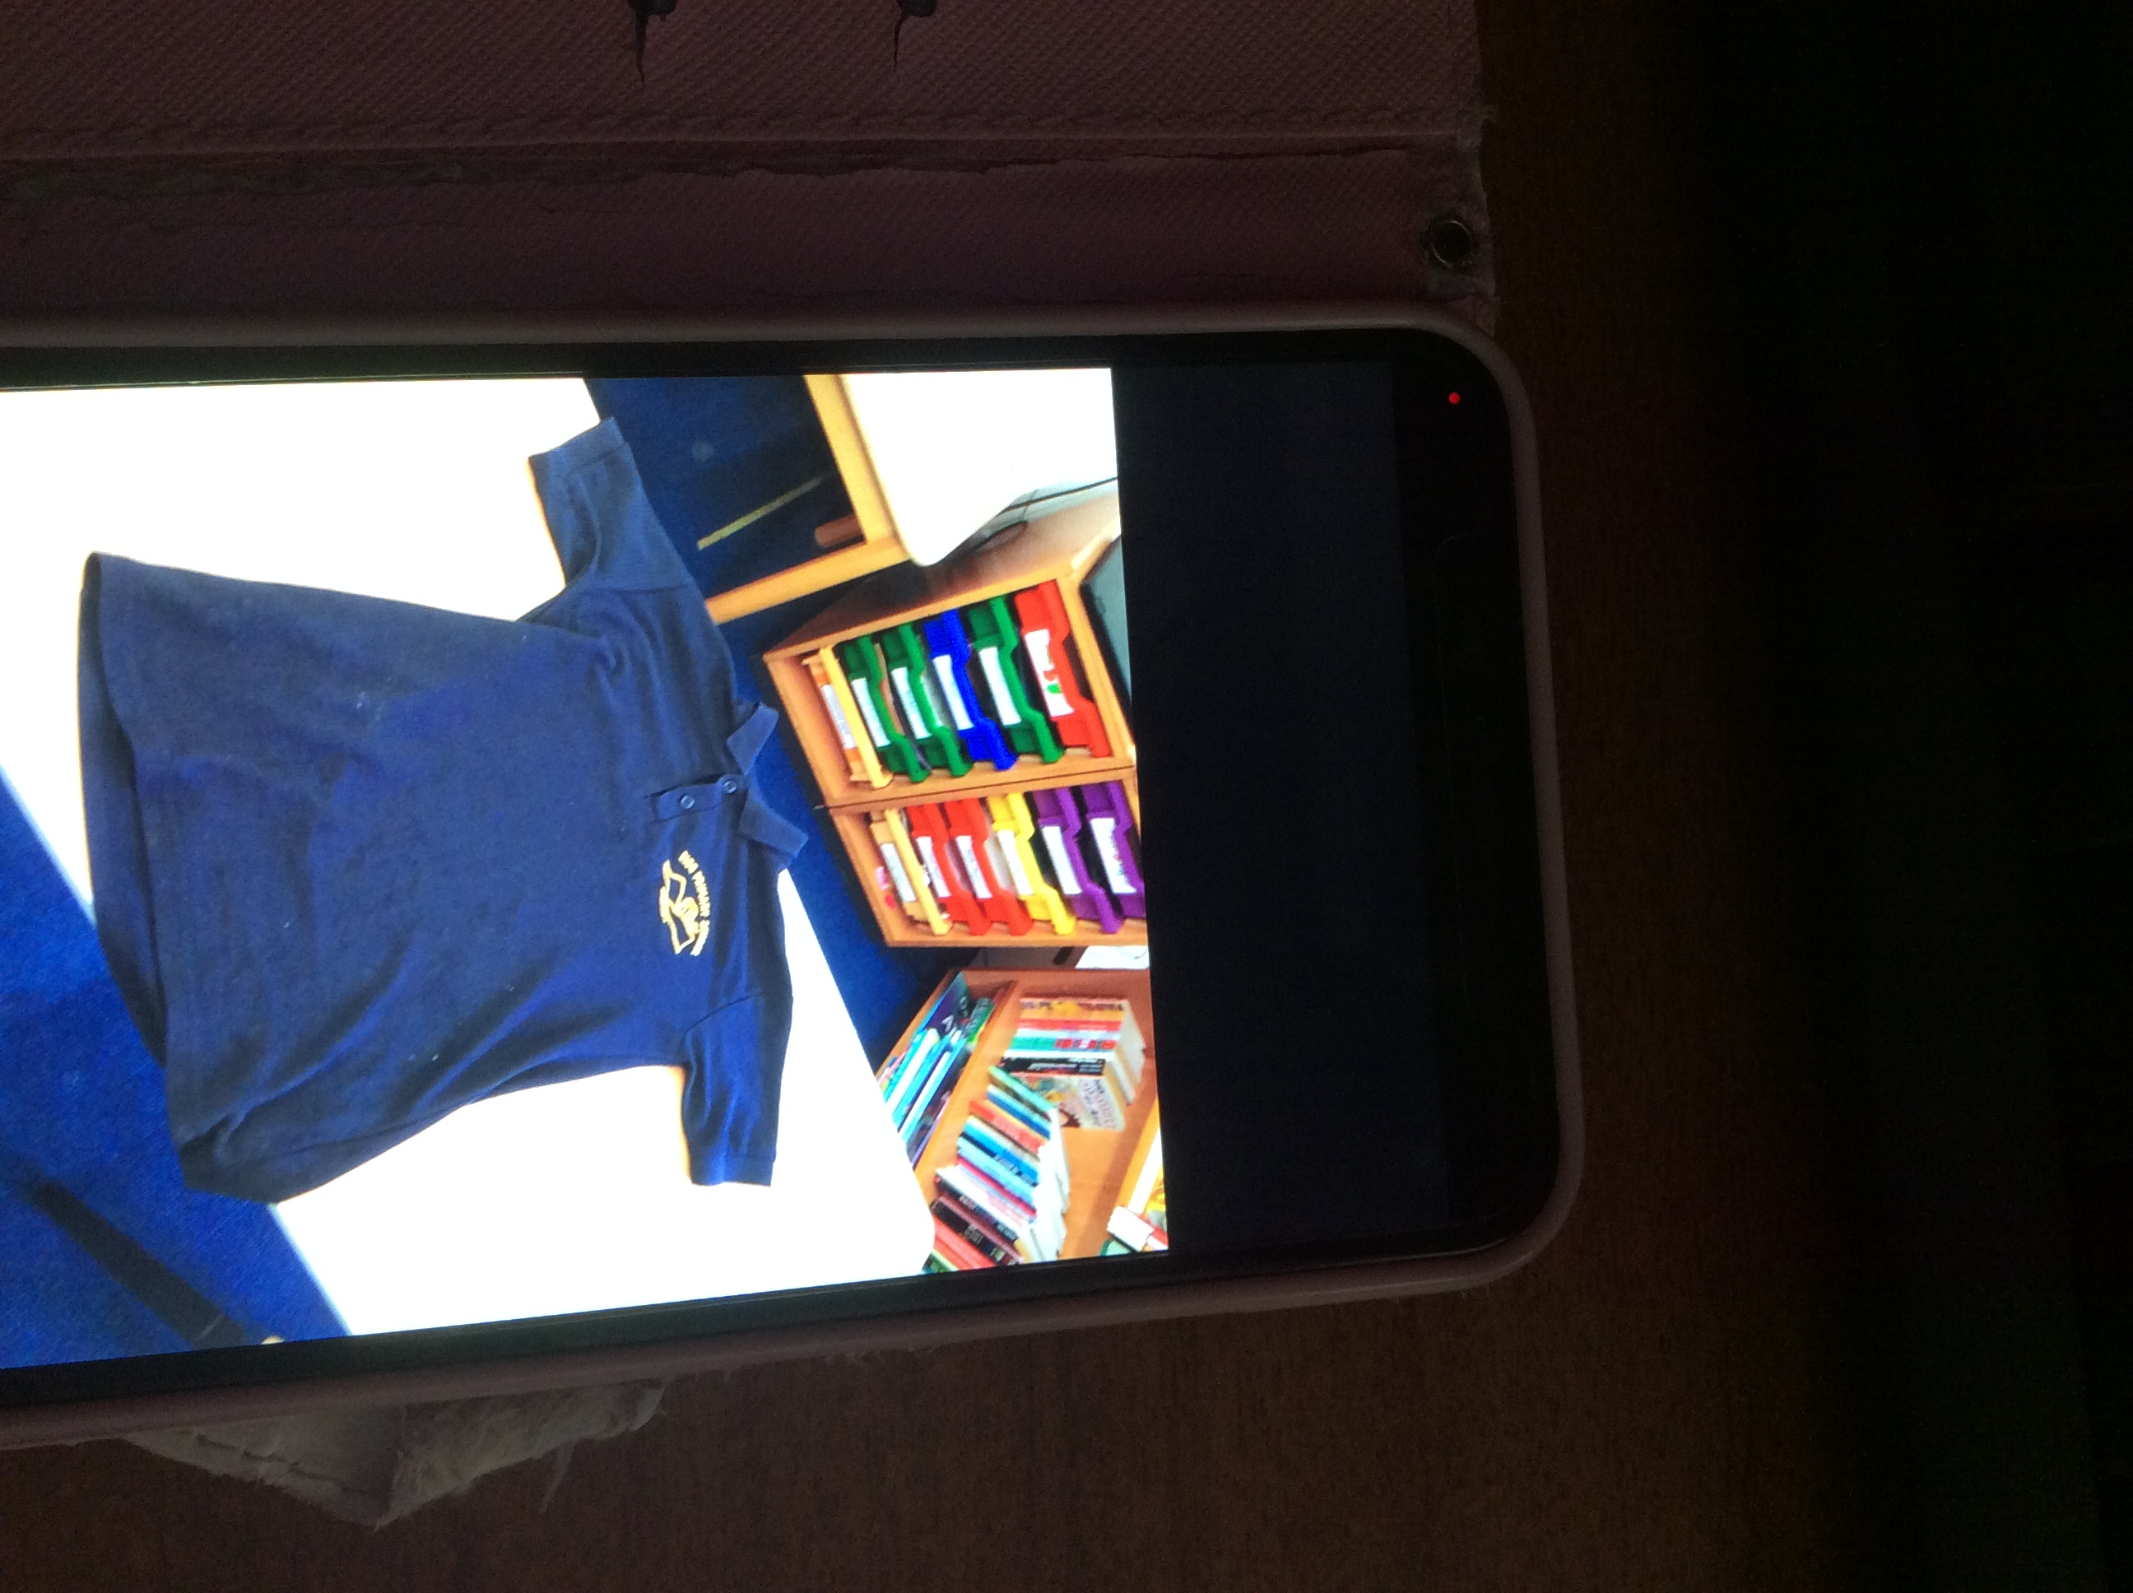

Children are asked to bring an inside pair of shoes with them to wear within the school building

As a lot of the learning in both the primary class and nursery takes place outdoors, children should bring suitable waterproof clothing and footwear with them to school.
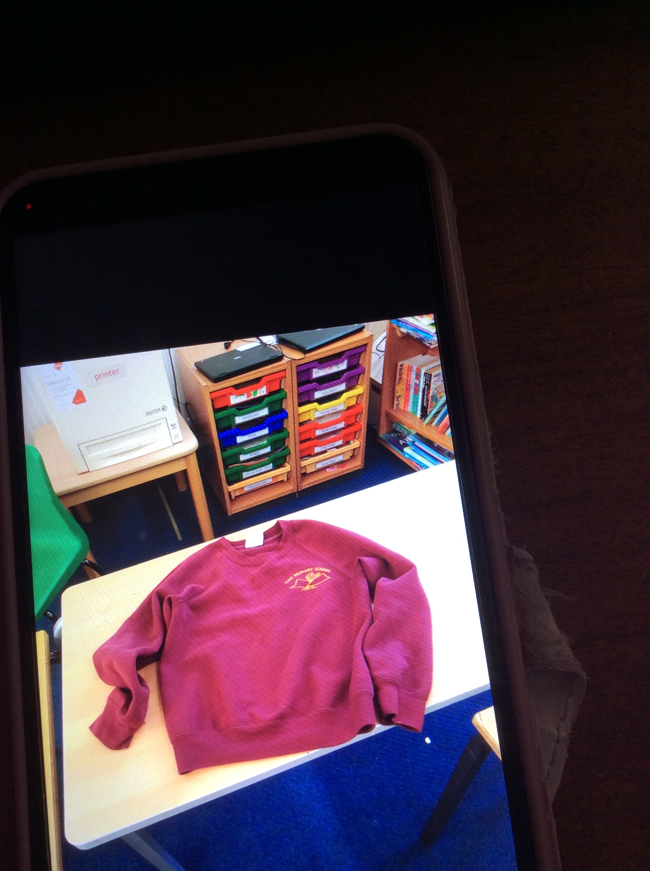

The nursery children are asked to have a spare set of clothes within the school.

Children should take gym kit to the hall with them on Thursdays. Each child has a pair of plimsoll shoes stored at the hall.

School Lunches
Nursery children who attend nursery for at least four hours a day are entitled to free lunches. Children in P1 to P5 are also automatically entitled to a free school meal. In Eigg Primary/Nursery, parents will be reimbursed the cost of providing a school meal for P1 to P5s at the end of each term. Information and how to apply for free school meals for children from P6 to P7 and for assistance with school clothing for all age groups can be found at –
https://www.highland.gov.uk/info/878/schools/9/school_meals.

School Transport

Your child may be eligible for free school transport if they are:
- Under 8 and live more than 2 miles from school
- 8 or over and live more than 3 miles from school
- Have a medical condition or additional support needs
- Would have to walk a route which is considered by us to be unsafe for children to walk, even when accompanied by an adult

You can apply for school transport at -https://www.highland.gov.uk/info/878/schools/12/school_transport
Information about the Highland Council’s school transport can be found at - https://www.highland.gov.uk/downloads/file/209/school_transport_policy

Enrolment

Enrolment week for prospective Primary 1 and Nursery pupils is held in January/February each year, and parents who are resident on the island will be informed beforehand. Prior to enrolment of their child, parents are encouraged to make an appointment to visit the school to discuss their child’s needs and requirements with the Head Teacher (Kieran MacInnes – Tel: 01687 462367 or 01687 482424 email: Kieran.MacInnes@highland.gov.uk).

Placing Requests – Parental Choice

Each school serves its own catchment area. The catchment area for Eigg Primary school is the entirety of the Island of Eigg.

Parents of children with additional support needs, (including those that have Coordinated Support Plans) can make placing requests to any school in Scotland including schools outside of the local authority area they live in. All appeals about placing requests to special schools will be referred to the Additional Support Needs Tribunal.
To discuss any aspect of enrolment or school placement, please contact Kieran MacInnes at 01687 462 367 / Kieran.MacInnes@highland.gov.uk in the first instance.

Further information can be found here:

We recognise that given our island setting, some of the guidance around placing requests will not be relevant.

Complaints and Requests for Service

If a parent has any concerns, they should contact their child’s Named Person/Head Teacher in the first instance, Kieran.MacInnes@highland.gov.uk. Parents of nursery children may wish to contact the head teacher or the Health Visitor team Tel: 01349 781410.

The school will always endeavour to resolve issues by listening to parents and seeking solutions in partnership.

Should a situation not be resolved, parents can contact the Area Quality Improvement Manager:
Kirsty Clark
01397 702620
Kirsty.Clark@highland.gov.uk

More information can be found by following this link - Complaints procedure.

Additional support can be found at https://www.children1st.org.uk/help-for-families/parentline-scotland/

note that transport is not a school responsibility, and any queries should be addressed to the local transport development, Linda MacQueen or by emailing the school transport mailbox below:
Linda.MacQueen@highland.gov.uk or emailed to school.transport@highland.gov.uk.

Data Protection

Access to Pupil Records
The Pupils’ Educational Records (Scotland) Regulations 2003 extend to parents the right of access (with certain specific exceptions) to any record held by the Authority in relation to their child. Parents may make application to the Head Teacher.

Data Protection Legislation
Information on pupils, parent and guardians is stored on a computer system and may be used for teaching, registration, assessment and other administrative duties. The information is protected by data protection legislation and may only be disclosed in accordance with the codes of practice.

Transferring Educational data about pupils
The Scottish Government and its partners collect and use information about pupils through the Pupil Census to help to improve education across Scotland. This note explains why we need this information, how we use it and what we do to protect the information supplied to us. Further information can be obtained from
http://www.gov.scot/Topics/Statistics/ScotXed.

Data about pupil preferred routes, preferred occupations and anticipated school leaving date is also collected from S3/S4 to support planning for leaving school. This information is shared with Skills Development Scotland. Further information about 16+ Data can be found here:
http://hi-hope.org/directory/listing/16plus-planning

Data policy
Information about pupils’ education is collected through our statistical surveys in partnership between the Scottish Government and Local Authorities through the ScotXed Programme which aims to help schools and Local Authorities by supporting efficient collection, processing and dissemination of statistical information. The Scottish Government then provides analysis of the data to support research, planning, management and monitoring of education services as well as to produce National Statistics publications.

Education data within Scottish Government is managed effectively by secure systems and is exploited as a valuable corporate resource, subject to confidentiality restraints. As part of its data policy, Scottish Government will not publish or make publicly available any information that allows individual pupils to be identified, nor will data be used by Scottish Government to take any actions in respect of individuals. Data is held securely and no information on individual pupils can or would be made publicly available by Scottish Government.

The individual data collected by Scottish Government through the Pupil Census is used for statistical and research purposes only.

Information on why we collect data about pupils and who we share this data with can be found in Highland Council’s Privacy Notice which is available here:

https://www.highland.gov.uk/directory_record/1095920/enrol_your_child_at_a_school

Why do we need your data?

In order to make the best decisions about how to improve our education service, Scottish Government, education authorities and other partners such as the SQA and Skills Development Scotland need accurate, up-to-date data about our pupils. We are keen to help all our pupils do well in all aspects of school life and achieve better examination results. Accurate and up-to-date data allows us to:

- plan and deliver better policies for the benefit of all pupils
- plan and deliver better policies for the benefit of specific groups of pupils
- better understand some of the factors which influence pupil attainment and achievement
- share good practice
- target resources better
- enhance the quality of research to improve the lives of young people in Scotland

Your data protection rights
The collection, transfer, processing and sharing of ScotXed data is done in accordance with data protection legislation. We also comply with the National Statistics Code of Practice requirements and other legislation related to safeguarding the confidentiality of data. Data protection legislation gives you the right to know how we will use your data. This note can give only a brief description of how we use data. Fuller details of each individual ScotXed survey, including the purpose of each and the published data, can be found on the ScotXed website:

http://www.gov.scot/Topics/Statistics/ScotXed/SchoolEducation

Scottish Government works with a range of partners including Education Scotland, Skills Development Scotland and the SQA. On occasion, in order to help meet our aim of improving the life of young people in Scotland, we may make individual data available to partners such as the National Registers of Scotland to carry out research relating to the national population census and also academic institutions and organisations to carry out additional research and statistical analysis to meet their own official responsibilities. Any sharing of data will be done under the strict control of Scottish Government, and will be consistent with our data policy. This will ensure that no individual level data will be made public as a result of the data sharing and that these data will not be used to take any actions in respect of an individual. Decisions on the sharing of data will be taken in consultation with relevant colleagues and individuals within and outwith Scottish Government. At all times pupils’ rights under the Data Protection Act and other relevant legislation will be ensured.

Concerns
If you have any concerns about the ScotXed data collections you can email the Head of Schools Analysis at ScotXed@scotland.gsi.gov.uk or write to The ScotXed Support Office, Area 2D, Victoria Quay, Leith, EH6 6QQ. Alternative versions of this page are available, on request from the ScotXed Support Office, in other languages, audio tape, Braille and large print.

Employment of Children

The employment of children byelaws regulate the types of occupation in which children under school leaving age may be employed and other conditions of employment. For further information please see:
http://www.highland.gov.uk/downloads/download/19/employment_of_children

Education Maintenance Allowances (EMA)

An EMA is a weekly payment worth up to £30 for pupils who are planning to stay on at school after their leaving age. They must complete a learning agreement at school for a minimum of 21 learning hours per week. Further information on full eligibility criteria and the online application process can be obtained from the school.
http://www.highland.gov.uk/info/899/schools_-_grants_and_benefits/14/education_maintenance_allowance

Adverse Weather and School Closures
If there is a need to close the school, parents/guardians will be contacted by immediate phone call on the school landline. An email and accompanying Seesaw post will also be sent out.

You can access the highland school closure information at -
http://www.highland.gov.uk/schoolclosures.

Policies

A list of Highland Council’s policies can be found here - Authority Policies

Military Families

Our school welcomes and supports families and their children and young people from Armed Forces families: Serving, Reservists and Veterans.
We understand some of the challenges that service life can bring. These may be more difficult during times of mobility, separation due to a deployment, long training exercise or weekending. We look forward to working with you to ensure your child or young person thrives whilst with us in Highland.
Please get in touch with us as soon as you can so we can work together to ensure we are ready for your child or young person joining us. This is particularly important if they have additional support for learning (ASL) needs so that we can where possible have the appropriate support in place. (ASL is the term used in Scotland, in England a similar term is SEND).
Highland Council proudly committed to the Armed Forces Covenant many years ago and have built positive relationships with its Armed Forces community. There is a unique and dedicated partnership, The Military Liaison Group (Education), often referred to as “The MLG” extend a warm welcome to you. This was formed to promote and ensure the equity and equality for any child or young person from an Armed Forces family, within an educational context, so that they thrive whilst with us in Highland.
There is a dedicated website in Highland, Armed Forces Families Website that has been developed and informed by our Armed Forces community’s needs. It is an easy to navigate website with helpful information, guidance and support for families, educators, children and young people and communities. Here is a link to take you directly to the Enrolment page which may be particularly helpful.
Our children and young people have co-created a warm welcome to you and your family. Click the link here Primary School Welcome.

Please get in touch with the Headteacher if you have any queries or if you would prefer, contact the MLG (Education) lead here.

Whilst the information in this handbook is considered to be true and correct at the date of publication, changes in circumstances after the time of publication may impact on the accuracy of the information.

