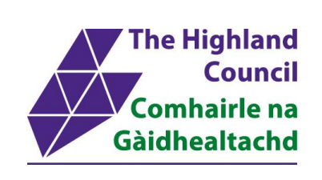
Eigg Primary School and Nursery
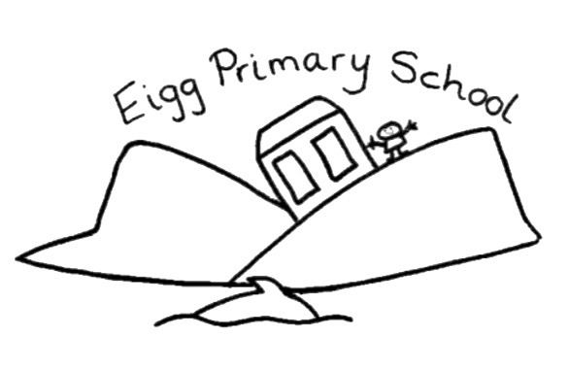
Promoting Positive Relationships/Anti Bullying Policy
Policy Created: 20.09.24
Last reviewed with staff, parents and partners: 17.09.25

Introduction to our School
At Eigg Primary School, our values of creative, active, respectful and resilient are at the heart of our daily practice. We want all our learners to live these values, as a foundation for future successes.
We are proud of our nurturing school and the support we provide one another. We are one team, achieving amazing things together. This policy allows children, staff, parents and partners to work together, to make our school a safe, inclusive environment where everyone has their wellbeing needs met.
This policy is based on appropriate guidance from our local authority, and unique aspects of our school.
We encourage everyone to consider and take responsibility for their own actions and understand that all actions have consequences – whether positive or negative. This is supported by our Growth Mindset ethos. It is ok to make mistakes, and we always work together to make things right.
The responsibility for pupil’s pastoral care lies mainly with the Class Teachers / Early Years Practitioners and the Head Teacher. This responsibility is also shared with and all support staff.
Parents are partners to this plan. We operate an open-door policy and parents are always welcome in our school. We encourage parents to get in touch with school staff to discuss, and school staff maintain regular communication with them.
Our Values in Action
Creative  “One size fit all solutions” don’t fit us! We find bespoke solutions that are right for us. | Active  We actively seek out ways to help and support one another. We take action to put things right, together.
Respectful  We respect each other, our environment and our community. We support children to access their rights. | Resilient  We try our best for ourselves and one another. We remember that it is ok, not to be ok and that each day is a fresh start.

A Framework for Positive Relationships
We have a variety of proactive ways to promote positive relationships:
- Restorative Approaches
Restorative practice is a way of working through conflict that puts the focus on repairing the harm that has been done. It is an approach to conflict resolution that includes all the parties involved. Restorative approaches are built on values which separate the person from the behaviour. They promote accountability and seek to repair any harm caused in a situation. Restorative approaches encourage children to reflect on the consequences of their actions, and work towards repairing any harm caused.
Research shows that restorative approaches help schools create peaceful learning environments for children to become successful learners, confident individuals, responsible citizens, and effective contributors.

Non-restorative (punitive) approaches can be ineffective, dangerous, breed resentment and make situations worse as a child or young person can be resentful of punishment rather than reflective of their actions.
A restorative approach may include having a ’restorative conversation’. These conversations may happen during the school day and practitioners will use restorative language and questions to allow children and young people to understand the impact of their behaviours.
More serious incidents may require practitioners to hold a formal meeting and involve parents or families where appropriate.
Examples of questions used in a formal meeting include:
• What happened?
• What were your thoughts at the time?
• What have been your thoughts since? • Who has been affected by what happened?
• How have they been affected?
• What do you need to happen now?
As part of the restorative approach, schools will decide on an appropriate timescale to review incidents, check that issues have been resolved and that children and young people are happy and progressing well.
Parents can support their children by:
- Encouraging your child to see things from other people’s points of view.
- Encouraging your child to be a good friend.
- Supporting your child to be a peer mediator.
- Learning together about children’s rights, including their right to human dignity, regardless of their behaviour.
- Understanding that children learn developmentally, including how they behave and how their behaviour affects others.
- Learning about shame and the impact of shame on children’s readiness to learn.
At Eigg Primary School we aim to create a positive atmosphere in which staff and parents work together for the wellbeing of the children. We expect our children to behave well and take responsibility for their actions. We recognise that parents and carers should be fully informed about their child’s behaviour and every effort is made to ensure that there is good communication between home and school. This may be in the form of a phone call or a chat after school. Some smaller incidents or issues may not be reported to parents, as they will be dealt with in school during restorative conversations.
We always allow time for children to calm down after any incident occurs, before a restorative conversation takes place.
- Rights Respecting Approaches
We are aiming to be a Rights Respecting School and demonstrate the values of the Convention of the Rights of the Child (CRC) at its heart. Our children work with their teacher to create a class charter.
Pupils at Eigg Primary School regularly have opportunities to learn about the Convention on the Rights of the Child. This convention states all the rights to which children in the world are entitled to. Articles 28 and 30 of the Convention state that all children have the right to an education and to learn. Article 12 states that all pupils have the right to participate and be included.

To protect these rights, staff and pupils will continue to try to:
Pupils | Staff
- Give our best in all we do  - Ask for help if we need it  - Have and show respect for all  - Respect the property of others Be kind  - Have a positive attitude | - Help make sure pupils are safe  - Know the pupils well  - Meet the needs of all learners • Help pupils if they are struggling  - Help pupils with friendships  - Treat everyone fairly and with respect  - Encourage everyone to join in  - Have a positive attitude

- Classroom Strategies
Our staff also have a variety of incentives and strategies to support pupils, this includes:
- Verbal praise – a quiet word, a public word, positive written comments
- Relationship building gestures; a smile, a thumbs up etc.
- Values based certificates and stickers, and postcards home.
- Supporting children to learn about emotional regulation using the zones of regulation.
- Sharing successes with parents on Seesaw
- Allowing access to quiet areas / sensory activities
- Being sent to another adult or the headteacher for praise.

Persistent Distressed Behaviour
In case of persistent distressed behaviour that is not solved through restorative conversations, that compromise the learning of themselves and, the following might occur.
- Initial verbal discussion of behaviour with clear expectations
- Discussion with Head Teacher/SLT of behaviour
- Being asked to sit out and reflect during break times – supervised by SLT
- A letter, phone call, email being sent to parent
We operate staged approach as follows, to minimalise persistent distressed behaviour:
- Verbal discussion and clear expectations made
- Further discussion with class teacher if the targeted behaviour continues
- Head Teacher Notified – a restorative conversation may occur at this time. The way in which the Head Teacher will deal with this behaviour will depend on the circumstances, with a focus on the safety, wellbeing and rights of all children involved
- Reflection time in school during a break/lunch – both with parental notification.
- Behaviour management meeting with staff and parents – with agreed solution focused actions.
In cases of persistent significantly distressed behaviour, the school will arrange meetings with parents, teachers and a member of the school management team in order to discuss next steps, so that this partnership can work together to bring about positive changes in behaviour. External help could be sought at this time.
Adults within the school community, staff and parents, will strive to set a good example for our children and model courtesy and respect.
Exclusions
Please see the Highland Council Exclusion Policy for detailed guidance. Exclusions children from an education setting is a rare occurrence, and possible actions must be taken to avoid this.

Playground Rules
Children need the space and time to play, interact in a social setting and to run off excess energy. Playtime should be fun and healthy for all our children. Playground rules are important to ensure that all pupils can benefit positively from playground activities.
At break time we would like all children to:
• Play safely
• Be respected by others
• Be happy in the playground

Children are expected to:
• Keep hands, feet, and objects to themselves
• Use kind, helpful or friendly language
• Follow the direction of adults
• Keep to our agreed playground rules.

Sudden and Extreme Behaviour
Our school prides itself on its positive ethos and the care and understanding learners show one another. On rare occasions a child may display behaviour that disrupts the normal functioning of the class such as:
• Refusal to obey their teacher’s instructions
• Violence
• Abusive behaviour
Then the following procedure should be adopted:
• Send for the Head Teacher or in the absence of the Head Teacher the Class Teacher / another member of staff. If the Head Teacher is not in the school building they would be phoned as soon as possible.
• Remove the child from class if safe for all to do so. If this is not possible, the class would move to an alternative space to allow space to de-escalate.
• Investigate the incident alongside the Head Teacher
• Log the incident using Seemis and notify the parents/carers.
• Take any appropriate action, in agreed with Head Teacher, while involving parents in the process.

Additional Support Needs
For some children these procedures may not be appropriate. In this case an Individual Behavioural Support Plan may be used to meet their needs. This would be in collaboration with all adults involved in the pupil’s wellbeing.

Eigg Primary Anti-bullying Policy
Bullying is repeated, deliberate behaviour which uses power to hurt, frighten or cause unhappiness to others.
This behaviour includes:
• Physical: kicking, hitting, punching, pushing, tripping and other forms of unwanted physical contact
• Verbal: threats, name calling, spreading rumours, persistent teasing about personal features, teasing about family or domestic situations, shouting, swearing, hurtful comments
• Emotional: taking friends away, tormenting, hiding, stealing or damaging property, using threatening gestures, exclusion from friendship groups, “ganging up” on people, sending offensive/threatening texts or emails
• Racism: threats or gestures against race, colour, creed or culture
• Threats: any threat to beat up, demand money or other form of intimidation or extortion
• Isolation: deliberately not including an individual in activities, exclusion from friendship groups.
We take allegations of bullying seriously and these will be fully investigated by staff and SLT. We will ensure that any incident of bullying is responded to as a priority and will work to reduce or eliminate occurrences of bullying at Eigg Primary School.The priorities are to stop the bullying and to change the bullying behaviour. Any student who has been involved in an incident of bullying will have restorative conversations with the Head Teacher to show that they understand the meaning of the term bullying.
Children will be explicitly encouraged to report to a teacher or other member of school staff if they are being bullied or if they see anyone else being bullied. The pupil reporting the bullying will always be taken seriously. Staff will listen sympathetically to those involved in the incident. The school will inform the parents of the pupils involved in persistent bullying. Consultations will begin to change the behaviour. Appropriate actions will be taken following discussion with the parent of the bullying child. Parents are asked to contact the school if they become aware of any incidence of bullying or have any concerns about bullying.

