Eigg Primary School – Learning, Teaching and Assessment Policy – This policy has been supported by the Highland Council Learning, Teaching and Assessment Framework.
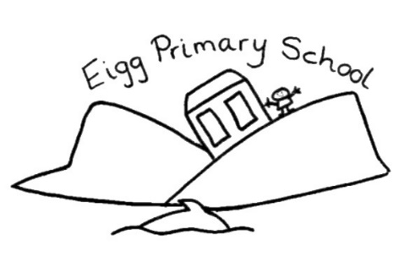
Our aim is for every Eigg Primary Learner to:
- Live our values of creative, active, respectful and resilient as a foundation for future success.
- Lead and love their own learning and be enriched and empowered buy their knowledge and understanding. Education should be an adventure; we can’t wait to see where it takes us.
- Support and nurture one another, we are one team and can achieve amazing things together.
- Gain the skills for learning, life and work that they need to thrive in our island and beyond.
- Enjoy learning in this special place, appreciate nature and our environment, sustain it, protect it and learn from it.
- Explore the world outside of our island and to share our island experience with the world.
To achieve these aims, we need to ensure that our school values are embedded in everything that we do:
Our Values | Adults will: | Learners will:
Creative | - Use their creativity to teach in exciting ways.  - Allow learners opportunities to apply creativity to all areas of learning.  - Provide choice as part of the learning process.  - Provide an environment that is stimulating and engaging.  - Support learners to make a plan to achieve their targets and goals.  - Promote higher order thinking, through stimulating questions, discussions and appropriate thinking time.  - Encourage a love of learning.  - Use learner’s prior knowledge as the starting point of lessons.  - Develop learners’ skills.  - Use digital technologies to enhance learning.  - Use formative assessment and effective plenaries to enhance learning.  - Differentiate tasks to support learners.  - Use learning intentions and success criteria, to support learner understanding.  - Make bilingualism a part of daily life in our school. All children experience Gaelic (L2) and French (L3) from P1-7, due to the multi-composite nature of our school.  - Seek out new contexts for learners to apply their learning.  - Have opportunities to lead developments in our school – including all staff, community partners and parents. | - Be free to change their mind.  - Solve problems and try new things.  - Recognise and celebrate their own and others’ creativity.  - Have meaningful choice and lead their learning.  - Help shape the classroom environment.  - Identify how they might achieve their goals.  - Work effectively as part of a team.  - Develop their own skills and recognise their progress.  - Use digital technologies to enhance learning and solve problems.  - Ask questions.  - Be open minded.  - Regularly co-create success criteria with support.
Active | - Make learning active, engaging and developmentally appropriate.  - Provide clubs and experiences that promote an active lifestyle.  - Provide two hours of high-quality PE.  - Take learning into the community and engage the community in the life of the school.  - Support children to gain skills and experiences from the wider world.  - Take global issues into our classroom.  - Use the outdoors to enhance learning.  - Provide trips that broaden children’s experiences.  - Celebrate wider achievement – including the Join in Scotland award.  - Actively look out opportunities for professional development and undertake regular self-evaluation, to make our school the best that it can be.  - Actively look outwith our setting to share ideas and moderate our own practice. | - Work hard, take part and try their best.  - Experience hands on and exciting learning, including learning through play for all ages.  - Take part in rich activities and clubs.  - Learn at the heart of our island community.  - Learn about the world outside of Eigg and engage with global issues.  - Take an active part in exciting and engaging trips.  - Protect our environment and promote sustainability.  - Be curious about and appreciate the natural world.  - Celebrate their achievements, both in school, at home and in the community.
Respectful | - Encourage and model positive relationships with our whole school community.  - Listen and respond to learner thoughts and opinions.  - Celebrate what makes our learners unique.  - Encourage learners to share their thoughts, opinions and ideas.  - Ensure our positive relationship policy is a living document.  - Engage families in the life of the setting.  - Celebrate diversity.  - Provide opportunities for children to socialise in larger groups and make new friends.  - Provide a balance of whole class, group and independent learning to meet the needs of all.  - Ensure inclusion is at the heart of our school.  - Communicate shared expectations and the purpose of learning.  - Take a restorative approach to promoting positive behaviour. | - Be kind to one another, kind to ourselves and encourage kindness to others.  - Recognise that everyone is different and value their contributions.  - Listen respectfully to others’ thoughts and opinions.  - Make new friends outside of Eigg, by visiting other settings and inviting other children to visit Eigg.  - Learn about a variety of cultures, religions and languages.  - Be supported to fully understand what they are learning and what is expected of them.  - Care for the school environment and our resources.
Resilient | - Promote and model a growth mindset.  - Have high expectations for all.  - Develop learners emotional understanding and wellbeing.  - Provide high paced and challenging lessons.  - Encourage learners to try new things.  - Give feedback and next steps to help learners progress.  - Make every day a fresh start for learners.  - Provide challenging opportunities to develop skills and learning through high quality daily writing, reading, phonics / spelling and numeracy (including problem solving and mental maths). | - Try your best, even when faced with challenge.  - Make mistakes and celebrate how this helps us grow.  - Complete tasks to the best possible standard.  - Assess their own and their peers’ learning, offering ways to make things even better.  - Try new things and embrace new experiences.  - Develop their understanding of their emotions and recognise that it is ok to have tricky moments and feelings.

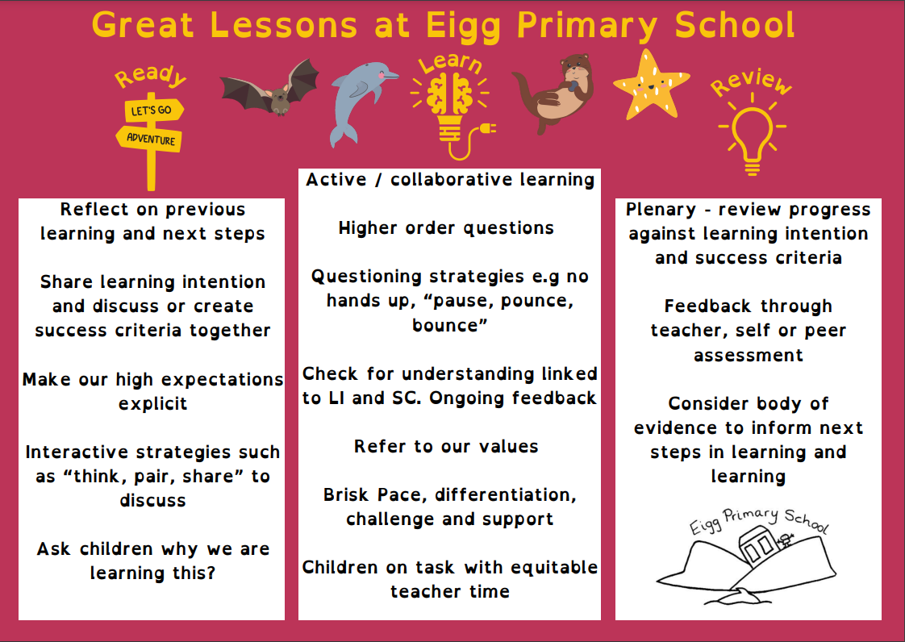
Our teachers use the Learning, Teaching and Assessment cycle to guide and inform practice:
